eDossier
Administrator Support Guide

Table of Contents
Manage Group Members of Workflow/Review Levels 3
Copy Members to Other Group 8
Manage Guest, Delegate, and Pre-Submissions Access Roles 9
Add an Access Role 9
Delete an Access Role 12
Descriptions of Default Workflow Levels 14
Workflow Levels and Routing in eDossier 15
Voting Eligibility Guidelines 17
eDossier FAQ and Resources 17

Manage Group Members of Workflow/Review Levels

- After logging into the eDossier application, click on the General Admin tab in the upper right hand corner of the page.
- The Navigation Pane will appear on the left. Click on the Admin Tasks folder to expand and show the items under “Admin Tasks.”
- Click on the Manage Group Members item to open in the main section of the web application.
- Follow the step by step instructions below:

Step 1:
Click on the Workflow dropdown menu to show the different types of workflow structures. Select the Default workflow option, as this is the most commonly used structure across Indiana University. Please note that the options that appear in the Workflow dropdown menu on your screen may be different from the screenshot below. These options will vary depending on your department, and if you know your department uses a unique workflow, you’ll need to select that option.

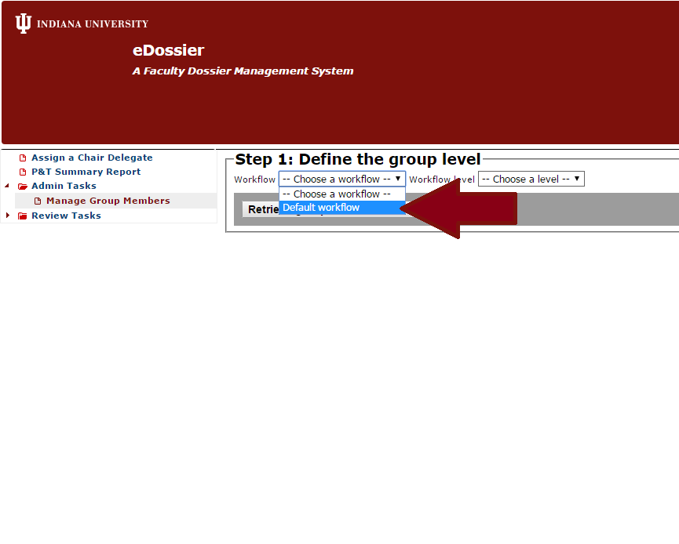

Step 2:
Click on the Workflow level dropdown menu to view the different review levels that you can manage. The levels that appear here will depend on your admin role in eDossier. For example if you are setup as a Department Admin, you will only be responsible for and have access to manage groups at the CheckListSignOff, Primary Unit/Department Committee, and Committee Chair (e.g. BL-ANTH or BL-MGMT). If you are setup as a School Admin, you’ll have access to the three above-mentioned “department” levels, and, in addition, School Committee and Dean. The screenshot below shows the levels available to School Admins.

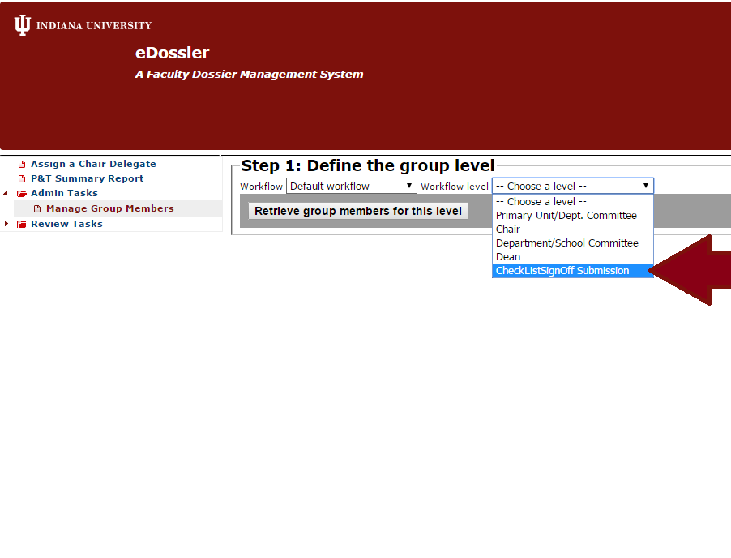

Step 3:
Once a Workflow Level has been selected, a Department dropdown menu will appear. In the following screenshots, the workflow level selected is “CheckListSignOff Submission.” Select the appropriate Department from the Department dropdown (e.g. BL-MGMT) and then click on the “Retrieve group members for this level” button. (Note: the Department dropdown menu will only show the departments or schools for which you are an administrator.)

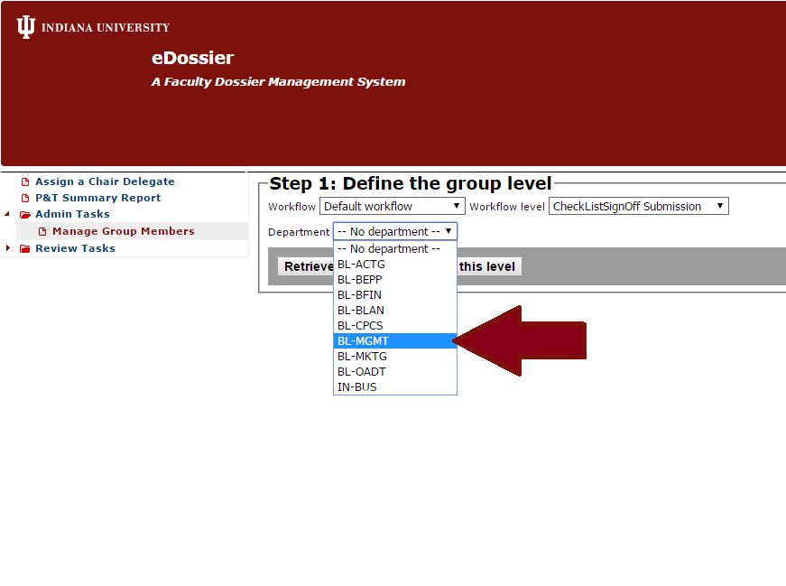

Step 4:
The current Group Members List for the workflow level and department/school will appear. To add member(s) at this level, enter the IU username of the person you which to add in the textbox and then click on the “Add” button. Then, click the “Save” button to complete. Once a member has been successfully added, you will see a “Success” confirmation message appear highlighted in green.

NOTE: It is important to note that you need to click the “Save” button to make sure that the user(s) were added to the group.

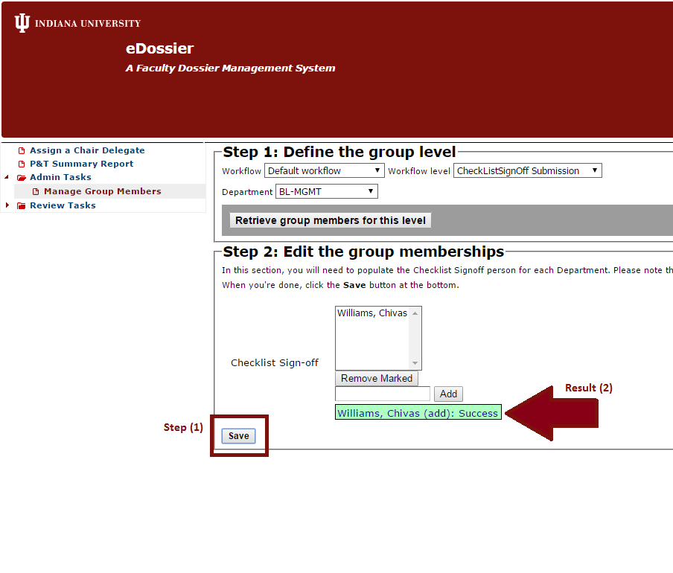

Once you have added and setup your committee member(s), it is a good practice to go back through and review Group Memberships at each workflow level to ensure that the users have been added correctly.

Remove/Delete Members

Removing members from groups follows a similar process than that of adding members. After selecting the Workflow level and appropriate Department or School, click on the “Retrieve group members for this level” button. To remove a user, select their name and click “Remove Marked” button. A browser message prompt will appear asking you to confirm the removal of the member, click OK. Then, click on the “Save” button at the bottom of the page. Once a member has been successfully removed, you will see a “Success” confirmation message appear highlighted in green.

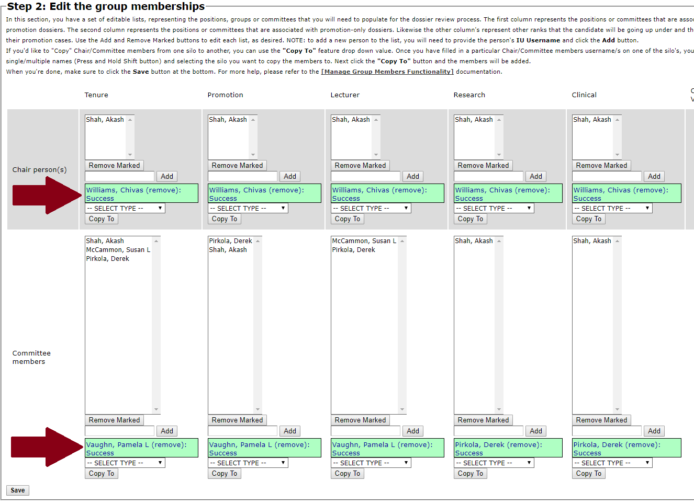

Copy Members to Other Group

In lieu of adding members individually as referenced above, you can save time by copying multiple group members from one dossier type group “silo” to another using the Copy To feature. In order to copy members from one silo to another, members must first be populated in at least one of the silos. (STEP 1) Select the particular members that you wish to copy by pressing CRTL + left click (PC) or Command/Shift + left click (MAC). (STEP 2) Click the dropdown menu above the Copy To button and select the silo that you wish to copy to. (STEP 3) Click on the Copy To button and the members will be added. (STEP 4) Finally, when you are finished editing/updating the group memberships, make sure to click on the “Save” button to complete. Once the members have successfully been copied over, you will see a “Success” confirmation message appear highlighted in green.

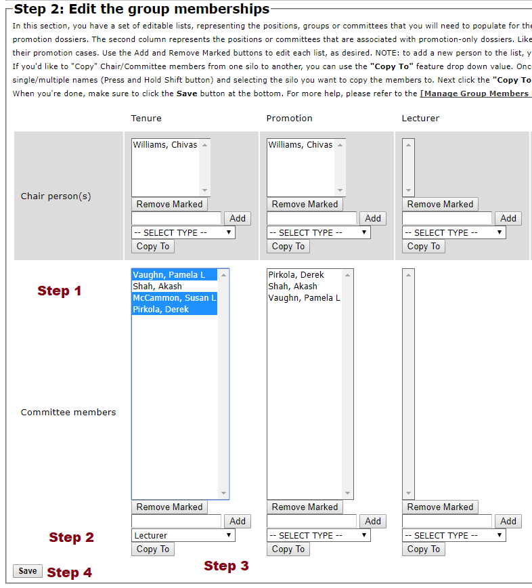

Manage Guest, Delegate, and Pre-Submission Access Roles

The Manage Guest, Delegate, and Pre-Submission Roles feature allow Administrators at the Department, School, or Campus levels, the ability to add, update, or delete "Delegate" or "Guest” or “Pre-Submission” roles on behalf of the candidate going up for Tenure and Promotion. As a candidate’s delegate, a user can view and upload candidate materials to the dossier. However, they do not have access to upload “Restricted Area” materials or the ability to submit/route a dossier. As a candidate’s guest, a user has “read-only access” and can review dossier materials for the candidate. A guest user can also view a dossier of any status it has been closed. Guest users cannot modify candidate materials. Similarly to a guest, Pre-Submission access grants a user the ability to review candidate materials with “read-only” permissions, but only before it has been routed/submitted. Unlike the guest role, this role will auto-expire once the dossier is submitted. On deciding which role to assign a user, use the chart below:

Role Name | Status(es) that Can be Viewed | Type of Access | Any Restrictions?
Candidate Delegate | -Open  -Submitted | View, Upload Documents | Cannot Submit dossier or view Restricted Area Materials
Guest | -Open  -Submitted  -Closed | View Only | Cannot upload documents, view Vote Records, External letters, Evaluative Letters
Pre-Submission | -Open | View Only | Cannot upload documents. Role will automatically expire once the candidate has submitted the dossier.

Add an Access Role

To add a Delegate, Guest, or Pre-Submission access role follow the below steps:

- Click on the Admin Tasks folder in the main navigation window to expand/open.
- Click on the Manage Guest/Delegate/Pre-Submission Roles feature under Admin Tasks.
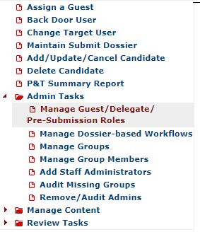
- Enter the IU Username of the person you would like to assign the access role to and click "search" button.
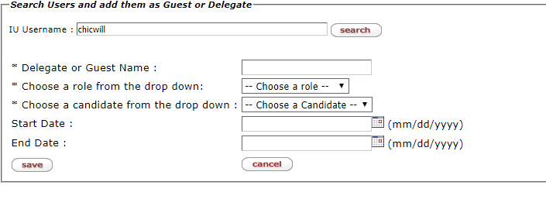
- The user’s full name will populate in the Delegate, Guest or Pre-Submission Name box if the username was entered correctly.
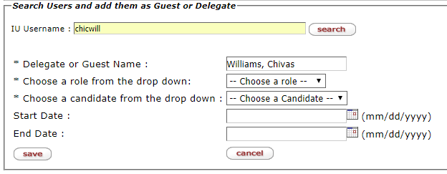
- Choose arole from the drop down (e.g: Candidate Delegate or Candidate Guest or Pre-Submission Access).
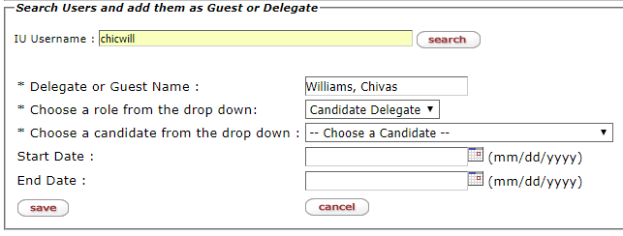
Once you choose a role to assign, the page will refresh with "Processing" flashing and after it verifies your administrator role, it will then display the candidate names that you can select from. (The list of candidates you will be able to select from will vary depending on your administrator level setup).
- Select the faculty candidate to assign the above user as a guest or delegate. (Note: if any guests or delegates currently exist for the candidate, they will appear below the tool.)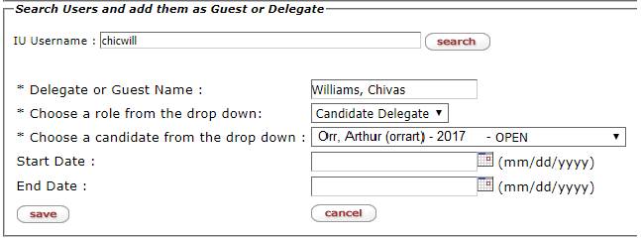
- Enter a Start and End Date if applicable, or, leave blank for open-ended access.
- Click on the Save button to finishing assigning the user as a guest/delegate.
- After the system has finished processing the addition of the guest/delegate, a confirmation will appear in red (“Save Complete”) and the user’s name will appear below the save button.
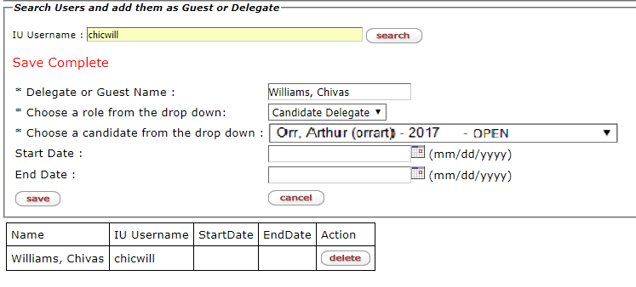

Delete an Access Role

To remove a Delegate or Guest follow the below steps:
- Click on the Admin Tasks folder in the main navigation window to expand/open.
- Click on the Manage Guest/Delegate/Pre-Submission Roles feature under Admin Tasks.
- Select the role (candidate delegate, candidate guest or pre-submission access) for the user you wish to delete.
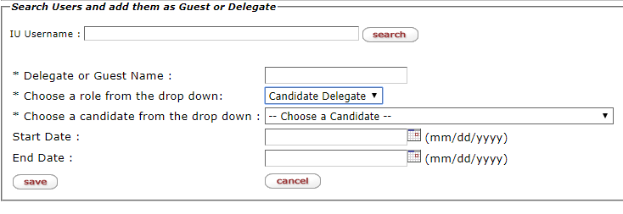
- Then, select faculty candidate to whom the role is assigned from the candidate drop-down list. The names of the currently assigned delegate/guests will appear below the tool.
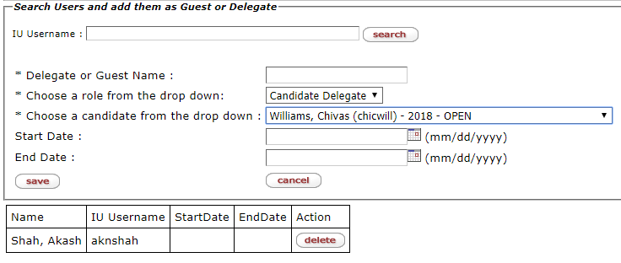
- Click on the delete button for the user you wish to remove.
- Once the user has been successfully removed from the candidate delegate/guest role, you will see a confirmation appear (“Deleted”) and the user will disappear from the screen.
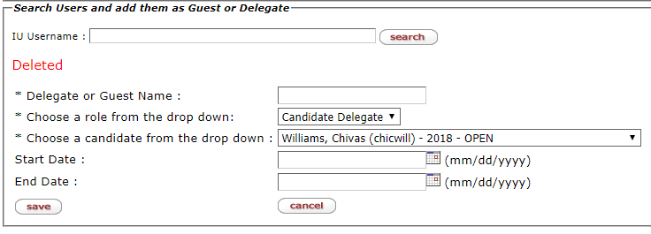

Descriptions of Default Workflow Levels

Checklist Signoff: Each department will need to have at least one Checklist Signoff person assigned to the group. In nearly all cases, this is the first stop for a dossier once the candidate has submitted it. It also provides an additional level of review/sign-off by someone other than the candidate, and before the dossier has entered the formal evaluation process. After selecting this workflow level and the Department and retrieving the group enter the checklist signoff UserID and click the ‘save’ button.

Primary Unit/Dept. Committee: You will need to enter at least one “Chair person(s)” for both Tenure (includes P&T) and Promotion along with any of the Committee members at the workflow level for each department. As a Department Admin you’ll be able to only add/setup members for your own department. If you are granted access as a School Admin, then you’ll be able to set up and manage group members for Primary Unit/Dept. Committee’s for Departments that are under your School if you wish to set them up if you handle your Dept./School committee’s setups done at the School level. If the case is P&T or Tenure only then you’ll enter all the committee members on the “Tenure” side of the column, if the case is “Promotion” only then you’ll enter the committee memberships on the “Promotion” side of the column.

Chair: You will need to enter at least one Chair person(s) for both Tenure and Promotion cases. As a Department Admin you’ll be able to only add/setup members for your own department, if you are setup with School Admin role then you’ll be able to add and setup Chair/s for Departments that are under your School if you wish to set them up if you handle your Dept./School setups done at the School level.

Department/School Committee: You will need to enter at least one “Chair person (s)” for both Tenure (includes P&T) and Promotion along with any of the School Committee members when selecting this workflow level for each department. This workflow level will only be visible and be accessible to the School Admin role/s users. You will also need to add School Committee’s for both “Tenure” and “Promotion” cases. If the case is P&T or Tenure Only then on the “Tenure” section is where you’ll enter Committee members. If the case is “Promotion” only then you’ll enter the committee memberships on the “Promotion” side of the column.

Dean: A Dean for the School must be entered for each workflow/School combination in the “Chair person(s)” section for both the Tenure (includes P&T) and Promotion sections.

NOTE: If your School does not use the “Default Workflow” the drop down options under the “Workflow level” field will appear differently than that of the descriptions above. You will need to add/remove committees member/s based on levels displayed for your specific workflow. If you leave a particular “Workflow level” blank (without members), it will skip that level or node. This is true in a case where a School does not have Primary/Unit Dept. Committee or Chair level voting. If your School does not have these levels of Vote/Letters to be recorded then you can leave the group memberships at those levels as blank and the application logic will skip those levels and directly go to the School Committee level.

Descriptions of Membership Groups

Tenure: Use this group to specify Chair and Committee members for Tenure-Track faculty candidates who are going up for Tenure (and Promotion). These group members are those that will review P&T cases. If the candidate holds a tenure-track title and is going up for Tenure and/or Promotion & Tenure, the members assigned at a particular workflow level will have the ability review to the candidate’s eDossier.

Promotion: Use this group to specify Chair and Committee members for Tenured Faculty cases who are going up for promotion only. Please note that the dossiers that this group reviews will not include the below NTT Ranks (Lecturer – FLX, Research – RSX, and Clinical – FCX) as those groups will be specified separately.

Lecturer: Use this group to specify Chair and Committee members for NTT Lecturer Faculty promotion. The groups at each workflow level will review dossiers for candidates with a FLX Salary Grade who are going up for promotion.

Research: Use this group to specify Chair and Committee members for NTT Research Faculty promotion. The groups at each workflow level will review dossiers for candidates with a RSX Salary Grade who have met the requirements and are going up for promotion.

Clinical: Use this group to specify Chair and Committee members for NTT Clinical Faculty promotion. The groups at each workflow level will review dossiers for candidates with a FCX Salary Grade who are going up for promotion.

Workflow Levels and Routing in eDossier

- Once the candidate submits their dossier, it goes to the "Checklist Sign Off" role/user. In most of the cases this is the Chair for the department. Once the checklist sign off user/s gleans over the candidate submitted materials and is satisfied, they log in the application and click the 'Submit' button under the Sign Off field to sign off and move the dossier into the formal evaluation and routing process. If they find an issue with the candidate materials, then the checklist sign off user has the ability to return the dossier back to the candidate by clicking the ‘return to candidate’ button. At which point, the system will then generate an email back to the candidate to let them know that their dossier has been returned. Note, that when the dossier is at the “Checklist Sign off” level, the “Dossier Status” will reflect “PENDING” status which indicates that the dossier has still not yet moved on to the committee and enter formal routing process and evaluation. Once the checklist sign off user/role has “signed off” on the dossier it then enters formal routing and at that point the “Dossier Status” will reflect the status of “SUBMITTED”.
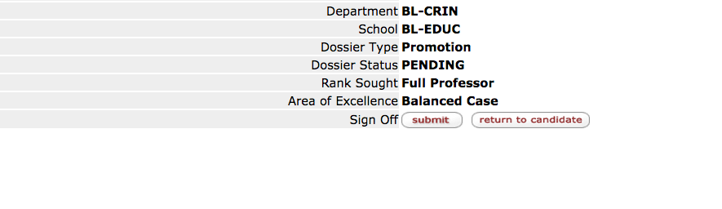

- If the checklist sign off user submits the dossier on to the next level, the dossier then enters formal routing and evaluation process and it is then routed to the “Primary Unit/Dept. Committee” workflow level. At that point the dept. committee members, along with the “Chair(s)” person/s of the “Primary Unit/Dept. Committee” will receive an email that the dossier is available with information on how to log in and view candidate materials. Once they login, the "Chair" for the "Primary Unit/Dept. Committee" has the ability to upload the Vote for the Dept. Committee level (tally all the votes and also upload the Internal Letter/committee report" under the "Internal Letters" folder that the Chair level person will have access to). The “Internal Letters” folder will have a “Review Layer” and the user will have to select the “Primary Unit/Dept. Committee” review layer when uploading the Dept. Committee report or the Dept. Internal letter/s. Please note that the Chair(s) of the "Primary Unit/Dept. Committee " is the person who will require entering the department vote and uploading the letter/s under these folders before the route button is visible to move the dossier further. Once the above routing requirements are met that's when they'll see a 'route' button appear, clicking on it will then move the dossier forward on to the “Dept. Chair/Chair Level”. 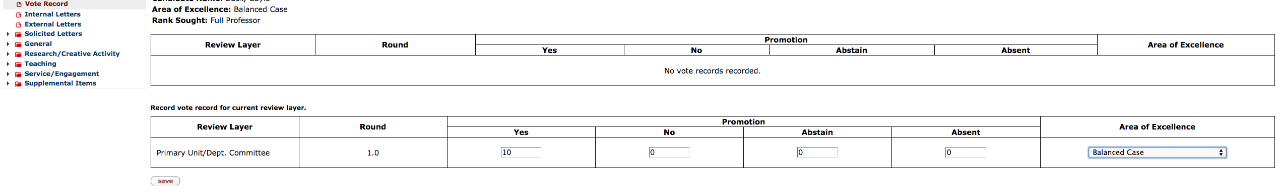

- After the Primary Unit/Dept. Committee chair person has moved the dossier on to the “Chair” level for the department it will go on to the “Chair” workflow level, which is when the Chair for the department will mark the Chair vote and upload the Chair’s Internal Review Letter to the Internal Letters folder under the "Chair Level" review layer. Once done the chair of the department has completed these actions and clicked the route button, it will then route the dossier ahead on to the School Committee.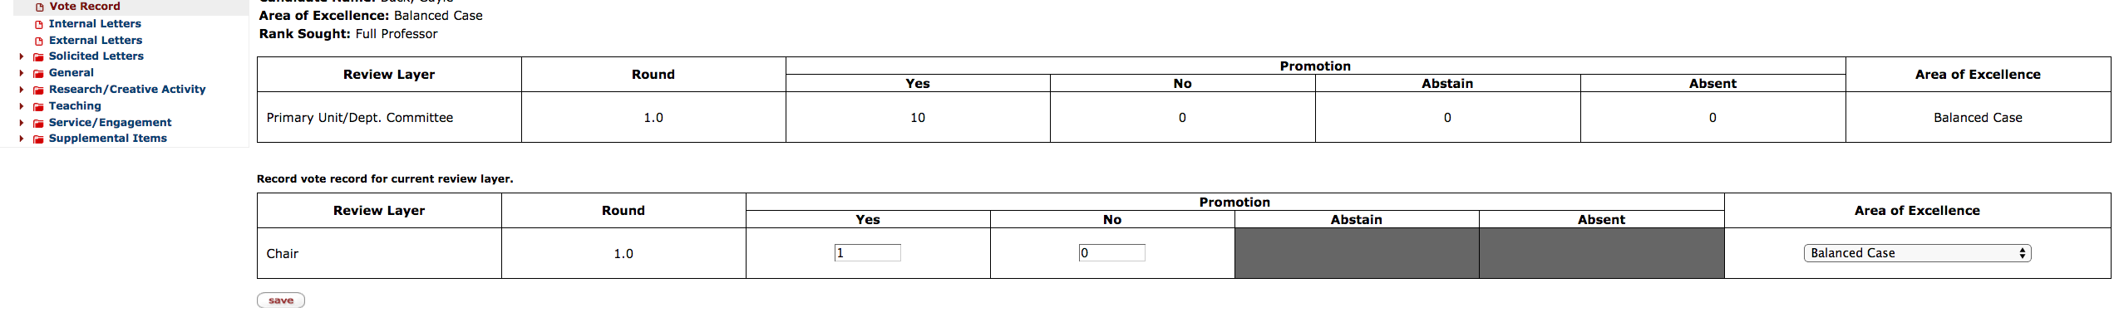

- The same process will be repeated to move the dossier further from the “School Committee” chair and once the Vote(s) and Internal Letter(s) are added they can route the dossier ahead on to the “Dean” level.

- Once the “Dean” provides the “Vote” and review letter they’ll then advance the dossier ahead to the “Campus Committee” workflow level onto > “Vice Provost/VCAA” level onto > “Provost/Chancellor” level onto > “President”.

*Please note that the above workflow routing process explanation is based off the Default workflow setup and the routing process will be different if they do not use the default workflow setup. If you leave a particular “Workflow level” blank (without members), it will skip that level or node. This is true to be the case in School’s that does not have Primary/Unit Dept. Committee or Chair level voting. If your School does not have these levels of Vote/Letters to be recorded then you can leave the group memberships at those levels as blank and the application logic will skip those levels and directly go to the School Committee level.

Voting Eligibility Guidelines

Voting eligibility is guided by the principle of rank appropriateness: only tenured faculty within a unit may vote on tenure cases; only full professors may vote on candidates seeking promotion to full. Retired faculty members may not vote. Please consult departmental or school governance documents regarding minimum FTE requirements for voting and committee eligibility and/or your campus academic affairs office.

eDossier FAQ and Resources

View our eDossier FAQ guide for answers to a list of Frequently Asked Questions.

Video Tutorial Available for the Manage Group Members Setup Functionality (URL: http://go.iu.edu/1uyF)

For departmental/school administrative user setup or other eDossier access requests/inquiries, please contact us at eDossier@indiana.edu.

