Creating Searchable PDFs

Scanning documents

If you scan using Adobe software, then it will be searchable.

Open Adobe Acrobat X Pro

Click on “Start”

Select “All Programs”

Click on “dobe Acrobat X Pro”

Click on “Create” and select “PDF from Scanner” then choose whether you want it to scan the document in color, black and white, etc.

If you are done scanning, click “OK” in the dialogue box that pops up. Or, continue adding pages until the file is complete.

Adobe will automatically convert the document into a searchable PDF.

Save the file.

If it is scanned some other way, you will need to make it searchable by:

Single File

Open the PDF file

Click on the “Tools” task pane

Select “Recognize Text”

Click on “In This File”

Click “OK” in the dialog box.

Save the file once Adobe is done processing.

Multiple Files

Open Adobe Acrobat X Pro

Click on the “Tools” task pane

Select “Recognize Text”

Click on “In Multiple Files”

In the dialog box that appears, select “Add Files” then select “Add Files” or “Add Folders”

Browse to where your files are on your computer, select them all and then click “Open.”

Click “OK” once your files have loaded into the dialog box.

Select your “Output Options” (default setting is fine) then click “OK.”

Click “OK” again.

With the default setting Adobe will overwrite the original files with the changes when it is done processing.

Converting electronic documents

When you convert a Word document into a PDF, the file is automatically searchable.

How you save a file as a PDF depends on what version of WORD you have installed on your computer.

Single File

Word 2010

Save your word file.

On the ribbon, select the “File” tab then printer.

Change the printer selection to “Adobe PDF.”

Change the printer selection to “Adobe PDF” then click the “Print” button.

Select where you want to save the file and what you want to name the file.

Word 2007

Save your word file.

On the ribbon, select the “Acrobat” tab then “Create PDF.”
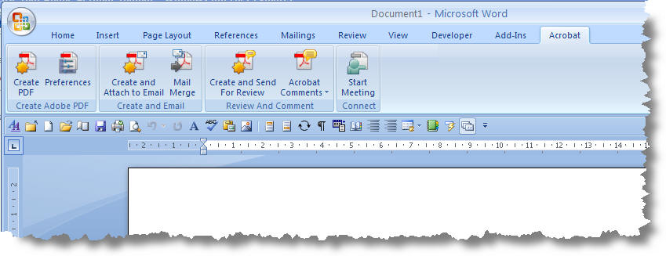

Word 2003

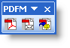
Save your word file.

Right-mouse click in the toolbar area and select the Adobe PDF Toolbar.

Click the first button.

Select where you want to save the file and what you want to name the file.

Multiple Files

If you have several Word files that you need to be converted into PDF files:

From your explorer window, select the files.

Then right-mouse click over the highlighted file selection.

In the pop-up menu, select “Convert to PDF.”

In the dialogue box, select the directory where you want the file saved and name the file.
You will repeat this step for each file you selected.

If you have several Word files that you want to combine into one PDF file:

From your explorer window, select the files.

Then right-mouse click over the highlighted file selection.

In the pop-up menu, select “Combine supported files in Acrobat.”

In the dialogue box, you can arrange the file order. The default is alphabetical. Click “Combine Files” button.

In the next dialogue box, select the directory where you want the file saved and name the file.

Converting Forms

Interactive PDF Forms must be saved as flat PDF files before you can use them in a multiple file conversion. Word forms convert as is.

For more instructions on working with PDF files, please consult the “Dossier Preparation Help” section on the P&T Resources Page of our website: http://academicaffairs.iupui.edu/PromotionTenure/IUPUI-Guidelines/Resources.

