Creating Searchable PDFs

Scanning documents

If you scan using Adobe software, then it will be searchable.

Open Adobe Acrobat Pro or Pro Extended

Click on “Create” and select “PDF from Scanner” then choose whether you want it to scan the document in color, black and white, etc.

If you are done scanning, click “OK” in the dialogue box that pops up. Or, continue adding pages until the file is complete.

Adobe will automatically convert the document into a searchable PDF.

Save the file.

If it is scanned some other way, you will need to make it searchable by:

Single File

Open the file

Select “Document” from the Menu Bar.

From the drop-down menu, click on “OCR Text Recognition” and then “Recognize text using OCR.”

Click “OK” in the dialog box.

Save the file once Adobe is done processing.

Multiple Files

Open Adobe Acrobat Pro or Pro Extended

Select “Document” from the Menu Bar.

From the drop-down menu, click on “OCR Text Recognition” and then “Recognize text in multiple files using OCR.”

In the dialog box that appears, you can use the drop-down menu to select “Add Files” or “Add Folders.”

Browse to where your files are on your computer then click “OK.”

Click “OK” once your files have loaded into the dialog box.

Select your “Output Options” (default setting is fine) then click “OK.”

Click “OK” again.

With the default setting Adobe will overwrite the original files with the changes when it is done processing.

Converting electronic documents

When you convert a Word document into a PDF, the file is automatically searchable.

How you save a file as a PDF depends on what version of WORD you have installed on your computer.

Single File

Word 2010

Save your word file.

On the ribbon, select the “File” tab then printer.

Change the printer selection to “Adobe PDF.”

Change the printer selection to “Adobe PDF” then click the “Print” button.

Select where you want to save the file and what you want to name the file.

Word 2007

Save your word file.

On the ribbon, select the “Acrobat” tab then “Create PDF.”
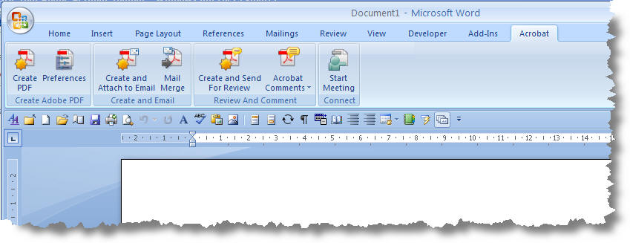

Word 2003

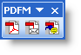
Save your word file.

Right-mouse click in the toolbar area and select the Adobe PDF Toolbar.

Click the first button.

Select where you want to save the file and what you want to name the file.

Multiple Files

If you have several Word files that you need to be converted into PDF files:

From your explorer window, select the files.

Then right-mouse click over the highlighted file selection.

In the pop-up menu, select “Convert to PDF.”

In the dialogue box, select the directory where you want the file saved and name the file.
You will repeat this step for each file you selected.

If you have several Word files that you want to combine into one PDF file:

From your explorer window, select the files.

Then right-mouse click over the highlighted file selection.

In the pop-up menu, select “Combine supported filesin Acrobat.”

In the dialogue box, you can arrange the file order. The default is alphabetical. Click “Combine Files” button.

In the next dialogue box, select the directory where you want the file saved and name the file.

Converting Forms

Interactive PDF Forms must be saved as flat PDF files before you can use them in a multiple file conversion. Word forms convert as is.

Manipulating PDFs

Deleting Pages

Open the file.

Select “Document” from the Menu Bar.

From the drop-down menu, click on “Delete Pages.”

In the dialog box, type in the pages you want removed from the file and click “OK.”

If you are sure you want those pages deleted, click “Yes” in the pop-up warning box.

Save the file once Adobe is done processing.

Extracting Pages

Open the file.

Select “Document” from the Menu Bar.

From the drop-down menu, click on “Extract Pages.”

In the dialog box, select your settings then click “OK.”

Type in the pages you want removed from the file.

Delete pages after extracting

Alters the original file

Places the removed pages in one single file

Extract pages as separate files

Original file remains the same

Removed pages are saved as individual files

If deleting, click “Yes” in the pop-up warning box if you are sure you want them deleted.

If deleting, save the original and the new file once Adobe is done processing.

Adding Pages

Open the file.

Select “Document” from the Menu Bar.

From the drop-down menu, click on “Insert Pages” then “file.”

In the dialog box, browse for the file you want then double-click on it.

In the next dialog box, select whether you want it inserted before or after then the page and click “OK.”

Save the file once Adobe is done processing.

Substituting Pages (or adding and removing in one step)

Open the file.

Select “Document” from the Menu Bar.

From the drop-down menu, click on “Replace Pages” then “file.”

In the dialog box, browse for the file you want then double-click on it.

In the next dialog box, select:

Pages in the original file you want replaced

Pages in the new file that are replacing the old pages (all or partial)

If you are sure you want those pages replaced, click “Yes” in the pop-up warning box.

Save the file once Adobe is done processing.

Rotating Pages

Open the file.

Select “Document” from the Menu Bar.

From the drop-down menu, click on “Rotate Pages.”

In the dialog box, select your settings:

Direction pages need to be rotated.

Which pages should be rotated.

Save the file once Adobe is done processing.

Tools

Typewriter
With the toolbar, you can adjust the settings

Advanced Editing
Touch-up Text

Comments
Touch-up Text

PDF Portfolio
Portfolios contain multiple files in one integrated unit, which can be in different formats and created in different applications. The original files retain their individual identities but are assembled into one PDF Portfolio file. Users can open, read, edit, and format each component file independently of the other component files within the portfolio.
NOTE:
- Adobe Reader users cannot create PDF Portfolios or edit the layout, colors, headers and so on.
- If a component file is not a PDF, anyone who receives the Portfolio may have to install the native application to preview that particular document.

Create a PDF Portfolio

Open Adobe Acrobat Pro or Pro Extended

Click on “Combine” and select “Assemble PDF Portfolio” from the drop-down menu.

In the task pane on the right-side of the screen, select “Grid with File Preview” as the layout.

Drag files from folder into the program.
OR
Select “Modify” then “add files”. In the dialogue box, navigate to where your files are. Double-click on a single file or Hold down the “shift” key to add multiple sequential files or hold down the “CTRL” key to select multiple files individually.
Please do NOT use the “add existing folder option.
FYI: By default the files are listed alphabetical order so be sure your files are labeled correctly before adding them.

Save the portfolio.

Portfolio’s should be labeled with the Candidate’s Last Name, First Name and your school’s HRMS Code:
Faculty, Joe HRMS

Transmitting Files

Create a folder labeled with your school’s HRMS Code.

Place PDF portfolio/binders for all of your school’s faculty in this folder.

Go back one level, select folder, right-mouse click and from pop-up window select “send to” then “compressed (zipped) folder.”

Upload the zipped file to https://www.slashtmp.iu.edu/. (You will be required to enter your CAS log-in information.)

Once you’ve uploaded your file, you will be required to give it a password then send an e-mail to ofaa@iupui.edu with the download link. You will need to send another e-mail to ckcole@iupui.edu with the password for the file.
Do NOT send dossiers or P&T spreadsheets via e-mail; files of this nature must be transmitted via secure means, such as https://www.slashtmp.iu.edu/ or Oncourse.

Within 48 hours of receiving the link, FAA will download the file, unzip and confirm receipt of the electronic files from your school.

By December 1st, FAA will review sections 00 through 02 and 09 for correctness. If there is a problem, the school will be notified of the issues. Corrected files are due NO LATER THAN December 16th.
NOTE: Issues with sections 03 and 04 may be found and addressed during the campus-level review.

RESOURCES

Andy Hunsucker’s Blog (UITS) - http://ittrainingtips.iu.edu/

Lynda Training Modules - http://ittraining.iu.edu/lynda/

